Ref. No.: IVM/KBIPER/Ex-Cu/2025-26/ Date: 15/06/2026

REPORT
01 | Date of activity | 05/06/2026
02 | Total Attendance | No. of Participated Students: 350  No. of Staff: 40
03 | Occasion of Activity | Farewell Ceremony "Chemonara–2026" and Annual Prize Distribution Function Report
04. | Objective | To bid a warm farewell to the outgoing D. Pharmacy, B. Pharmacy, and M. Pharmacy students and celebrate their academic journey. To recognize and honor students for their outstanding achievements in academics, sports, research, and co-curricular activities. To inspire students for their future careers through guidance, motivation, and interaction with faculty and dignitaries.
05 | Summary Report | The Farewell Ceremony “Chemonara–2026” and Annual Prize Distribution Function was successfully organized on 5th June 2026 at Krishnarao Bhegade Institute of Pharmaceutical Education and Research under the aegis of Indrayani Vidya Mandir Sanstha. The event was conducted to bid farewell to the outgoing D. Pharmacy, B. Pharmacy, and M. Pharmacy students and to recognize outstanding achievements in academics, sports, research, cultural, and co-curricular activities.  The program was graced by Prof. (Dr.) Narendra Narve, Campus Director of Indrayani Vidya Mandir Sanstha, and Mrs. Nirupa Kanitkar, Treasurer of the institution, along with Dr. Sanjay Arote, Principal of the B. Pharmacy College, Dr. Gulab Shinde, Principal and Head of Department, faculty members, staff, and students. Dr. Sanjay Arote welcomed the gathering and highlighted the achievements of the graduating students.  During the prize distribution ceremony, meritorious students were honored with mementos and certificates. Prof. (Dr.) Narendra Narve emphasized the importance of time management, discipline, and dedication, while Mrs. Nirupa Kanitkar encouraged students to develop resilience and learn from setbacks.The outgoing students shared their experiences and expressed gratitude to the management, faculty members, and staff for their continuous support. The event also featured cultural performances organized by students, creating a memorable and joyful atmosphere. The program was compered by Ms. Vedika Chorge and Ms. Divya Kalawade, and the vote of thanks was delivered by Dr. Gulab Shinde. The successful organization of the event was made possible through the dedicated efforts of Prof. Ashvini Joshi, Prof. Shweta Mantri, all teaching and non-teaching staff, and the active participation of students.
06 | Activity co-coordinator | Ms. A.V.Joshi  Ms. Shweta Mantri
Geotag photos of Farewell Ceremony "Chemonara–2026" and Annual Prize Distribution Function
Chemonara–2026: Celebrating Excellence & New Beginnings with Lakshmi Pujan  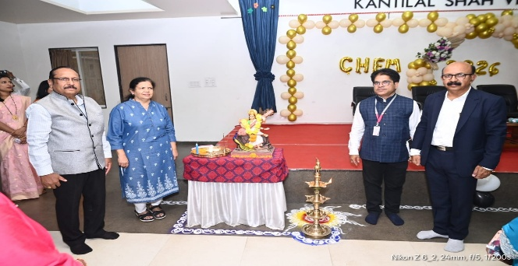  Hon’ble treasurer Ms.N.kanitkar Mam Speech  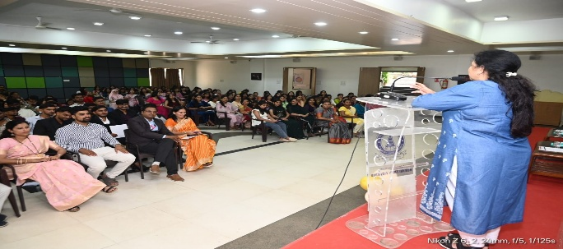  Moment of occasion  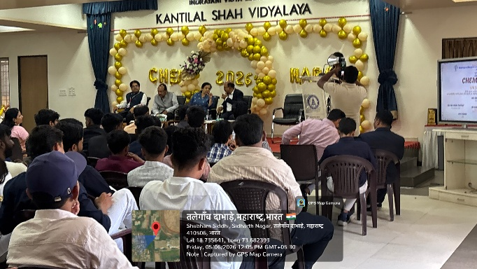  Farewell with Pride, Memories for Life  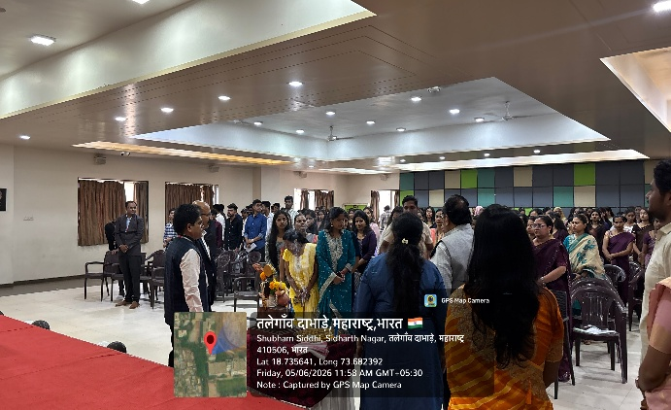 | Chief Guest Speech  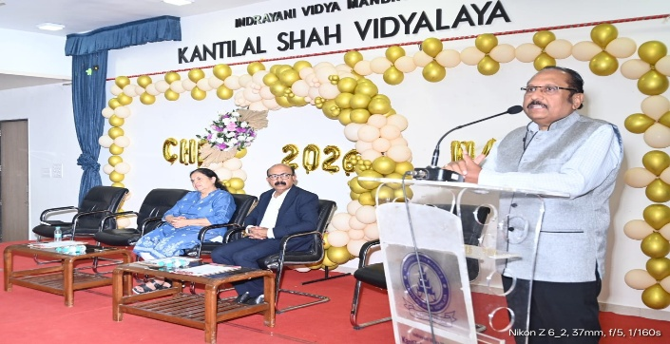  Principal sir Adressing Students  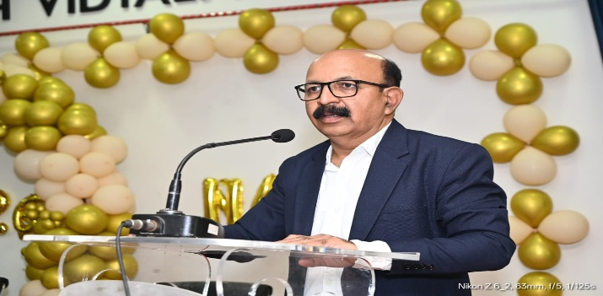Honoring Talent and Achievement  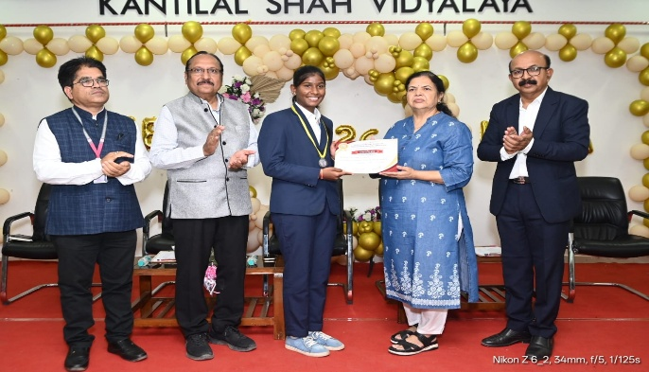  Vote of Thanks-Dr.G.S.shinde  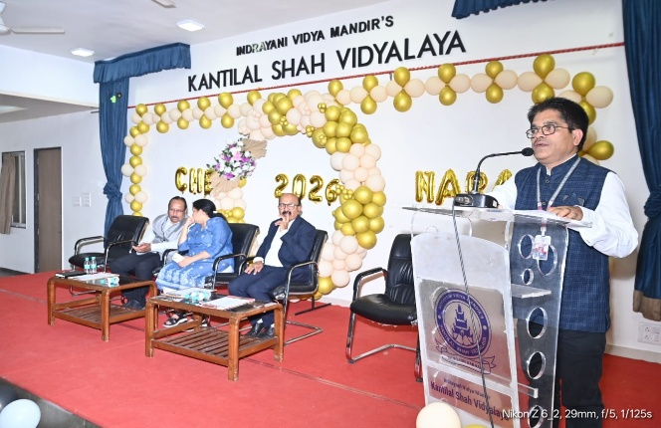

Extracurricular Coordinator IQAC Head HOD Principal
Ms. A.V.Joshi Dr.Y.B.Zambare Dr.G.S.Shinde Dr. Sanjay R. Arote
Ms. Shweta Mantri

